PRH - INTERNATIONAL  PRH belongs to the family of sciences exploring and researching the developmental processes in the human person.  It provides:  - 9 to 12-hour introductory workshops  - A series of 30- & 24-hour workshops  - Follow-up groups  - Individual accompaniment, (counselling)  - A self-directed methodical growth program  PRH is a method of self-discovery leading to greater fulfilment, happiness and tranquility.  It is a worldwide association of over 300 licensed professional Educators whose work fosters the full development of the human person.  Founded by André Rochais, incorporated in 1971, its headquarters are located in Poitiers, France. In Canada there are two legally incorporated groups with offices in:  - Langley, BC  - Sherbrooke, Quebec  Visit our Web Sites at:  www.prh-canada.com  www.prh-international.com | Helping My Children Become Themselves  Discover what fosters the development of a child’s unique personality and your potential as a parent  Objectives:  - A better understanding of your children and of their needs, and, in this way, foster their development.  - Significant improvement in your relationship with each child.  - Understand the cause of certain behaviours in order to manage the difficulties encountered.  - Enable each child to find their place in the family and their actual environment  This 24-Hour Workshop is for:  all parents regardless of their children’s age (and also grandparents who want to look at their relationship with their grandchildren).  Approach:  The unique PRH approach   teaches a method of written self-analysis based on personal experience.   invites you to share your experience if you wish.   provides facilitator’s feedback and PRH Observation Notes (handouts).  A PRH Workshop Takes Place In a  Respectful, Non-Judgmental Atmosphere | Helping  My Children  BECOME  THEMSELVES  Discover what fosters the development of a child’s unique personality and your potential as a parent  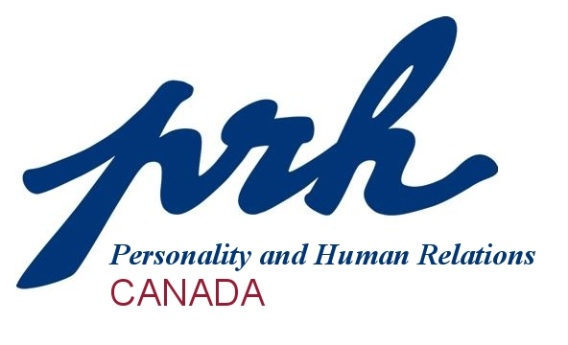
REGISTRATION FORM | FEES Helping My Children Become Themselves
Name: ___________________________________  Address: _________________________________  _________________________________________  Postal Code: ______________________________  Phone: ______________ (Cell) _______________(H)  Email ___________________________________  This workshop will take place by videoconference using Zoom.  Workshop: Scale of Fees  My fee according to the fee scale $ __________  Amount included: $ __________  E-transfers accepted to lbittante2@gmail.com  or  Make cheque payable to:  Harmony Personal Growth  Please return this form with requested deposit of $50 or full payment to:  Leah Bittante  20537 40th Avenue  Langley, BC, V3A 2X5 | Workshop fees are determined according to a sliding scale of fees, which takes into account the financial means of each participant.  Should it be impossible for you to pay the fee based on the scale of fees, contact the educator who will help you explore payment options.  Registration Fee: based on scale of fees. |  | Registration:  - Complete the registration form and return that section.  - A $50 deposit is requested at least one week before the workshop. The balance is due at the beginning of the workshop or may be paid in instalments if prior arrangements are made with the educator.  - Registrations are accepted on a “first-registered” basis once a deposit or full payment is received.  - Enrolment is limited to 15 persons.  - There are no prerequisites for this workshop.  Facilitator: Leah Bittante  604-613-0023  lbittante2@gmail.com  Online: Video Conference with ZOOM  Date: Over two weekends:  October 17, 18 and 24,25, 2020  Time: 9:00 am – 5:00 pm  Cost: See Scale of Fees  FOR MORE INFORMATION, PLEASE  CALL LEAH BITTANTE:  604-613-0023
  Fee for a Four-day workshop
  Income Level | Cost per workshop
  $60,001 and up  $50,001 to 60,000  $40,001 to 50,000  $30,001 to 40,000  $20,001 to 30,000  $15,001 to 20,000  $15,000 and under | $504  $480  $435  $351  $282  $222  $193

